# ***How To Set Up a Virtual Machine Using VirtualBox and Windows***

## **Prerequisites**

Before you begin, make sure you have the following:

* Oracle VirtualBox ver7 installed on your computer. [Download Link for VirtualBox](https://www.virtualbox.org/wiki/Downloads)
* ISO file of the Windows operating system. [Download Link for Windows10 iso](https://www.microsoft.com/en-us/software-download/windows10)

## **Step-by-Step Instructions**

1. **Launch Oracle VirtualBox**: Start the Oracle VirtualBox application on your computer.
2. **Create a New Virtual Machine (VM)**:

Click on “New” to create a new VM. Alternatively, in the top left corner, choosing Machine and New will do the same.

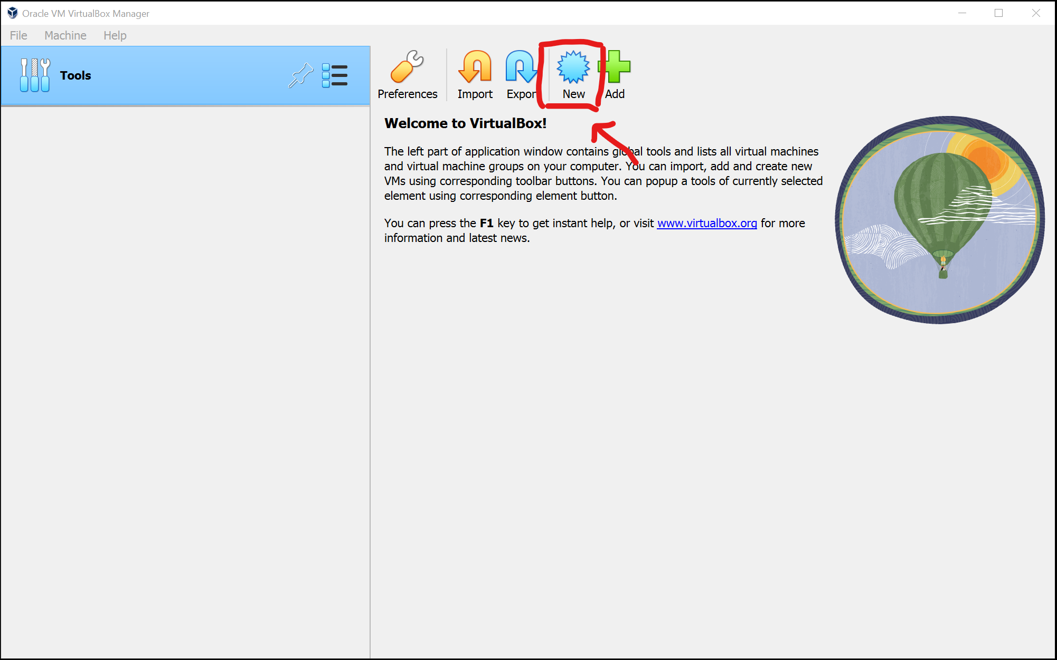

Enter a name for your VM, I chose DC as I will use this VM as a server for a home lab. Choose the version of Windows you are installing. For this I am using Windows Server2019.

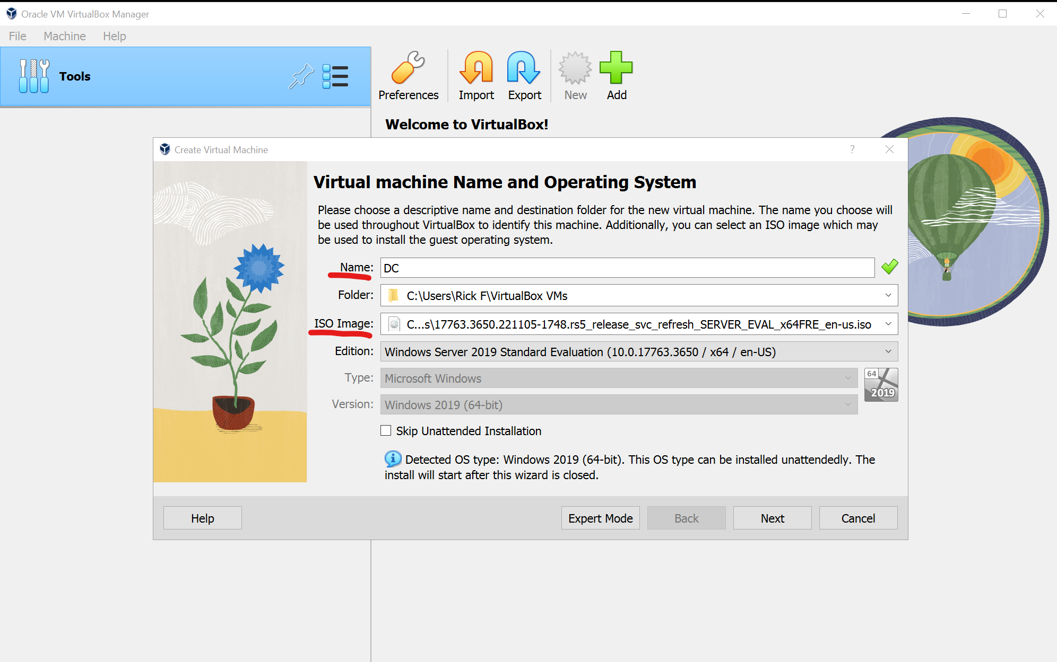

1. **Allocate Memory and Processors**: Choose the amount of RAM and CPU for your VM. The recommended minimum of RAM is 2GB. It is advised to not assign more than half of the total processor threads for the CPU. Select the appropriate amount for your VM as these resources come from your physical machine.

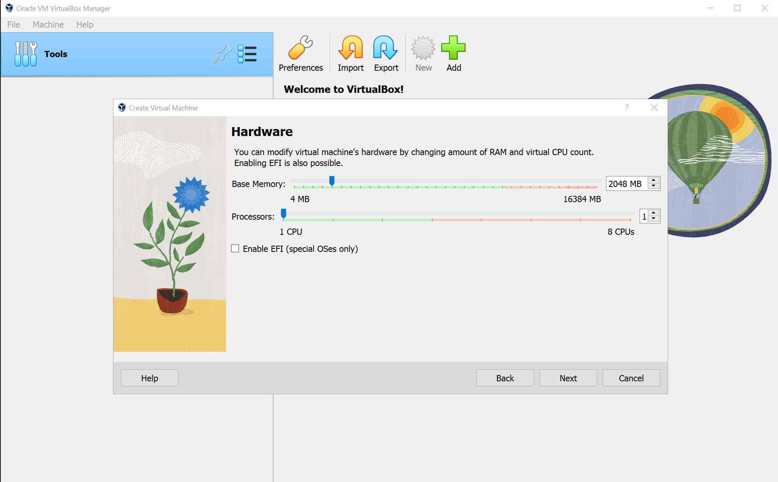

1. **Create a Virtual Hard Disk**: Choose “Create a virtual hard disk now.” You can choose either “Dynamically allocated” or “Fixed size” for storage on the physical hard disk. Assign a file location and size and click “Next”.

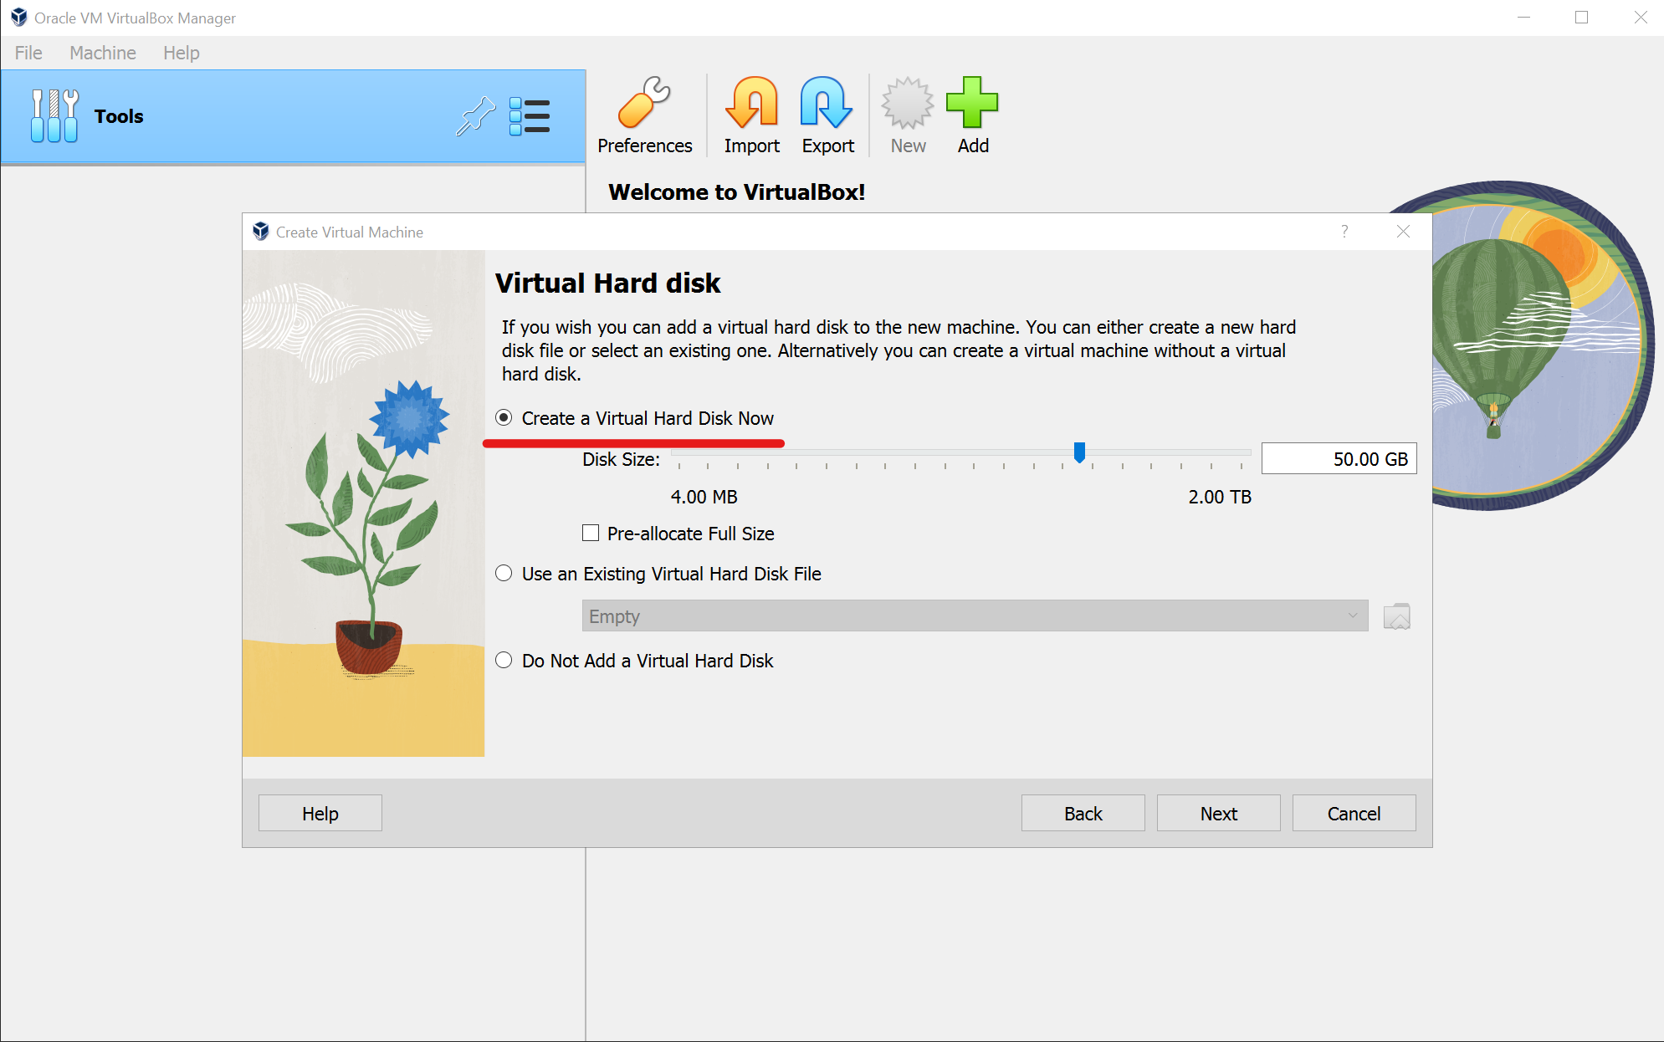

1. **Install Windows on the VM**: The next window is a summary of the VM, check your settings. If you are satisfied with it click “Finish” to complete the wizard. Select Settings to make configuration changes to your VM. This is where you can modify hardware, network adapters and more. For this VM I will be adding another network adapter for a home lab later.

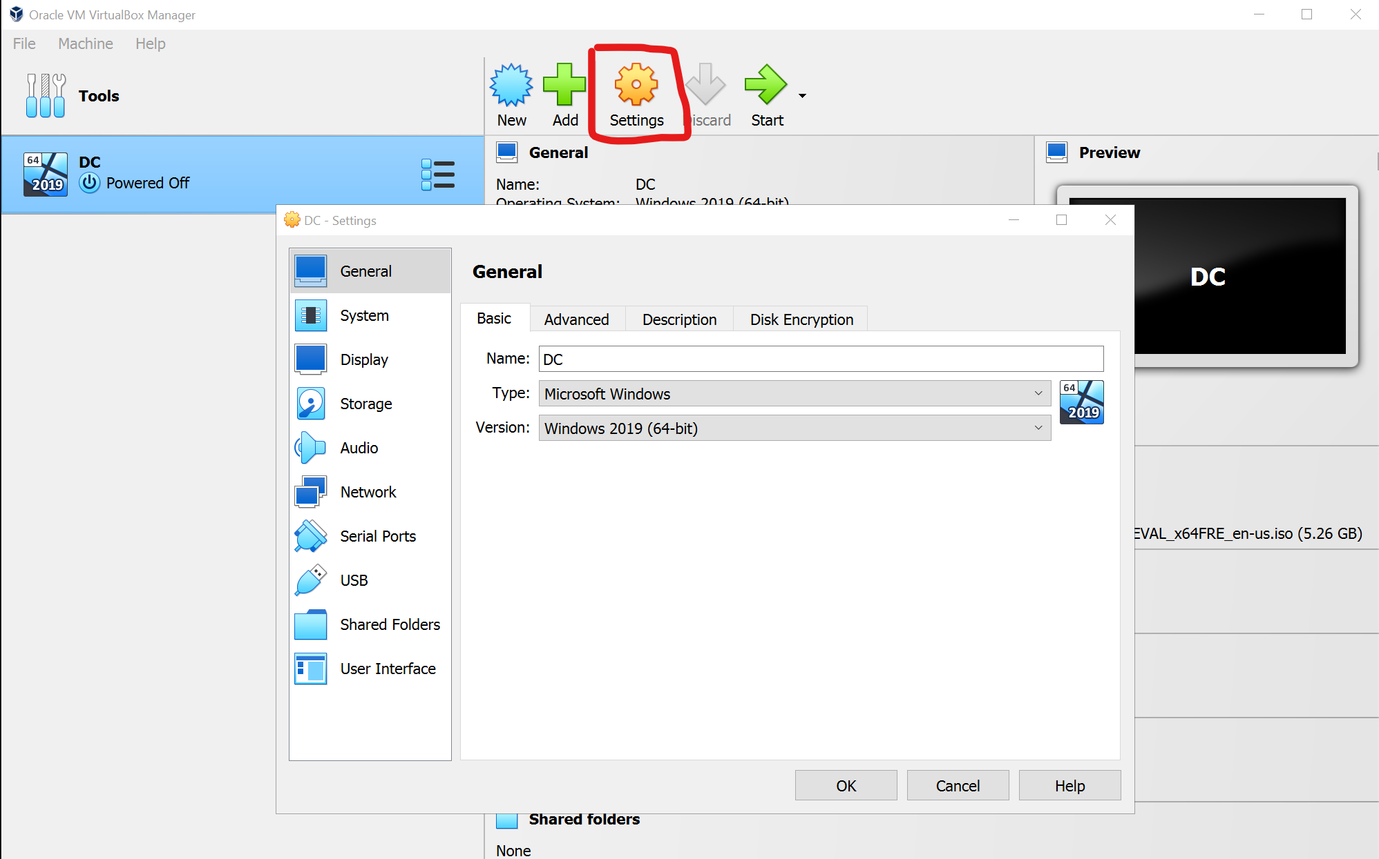

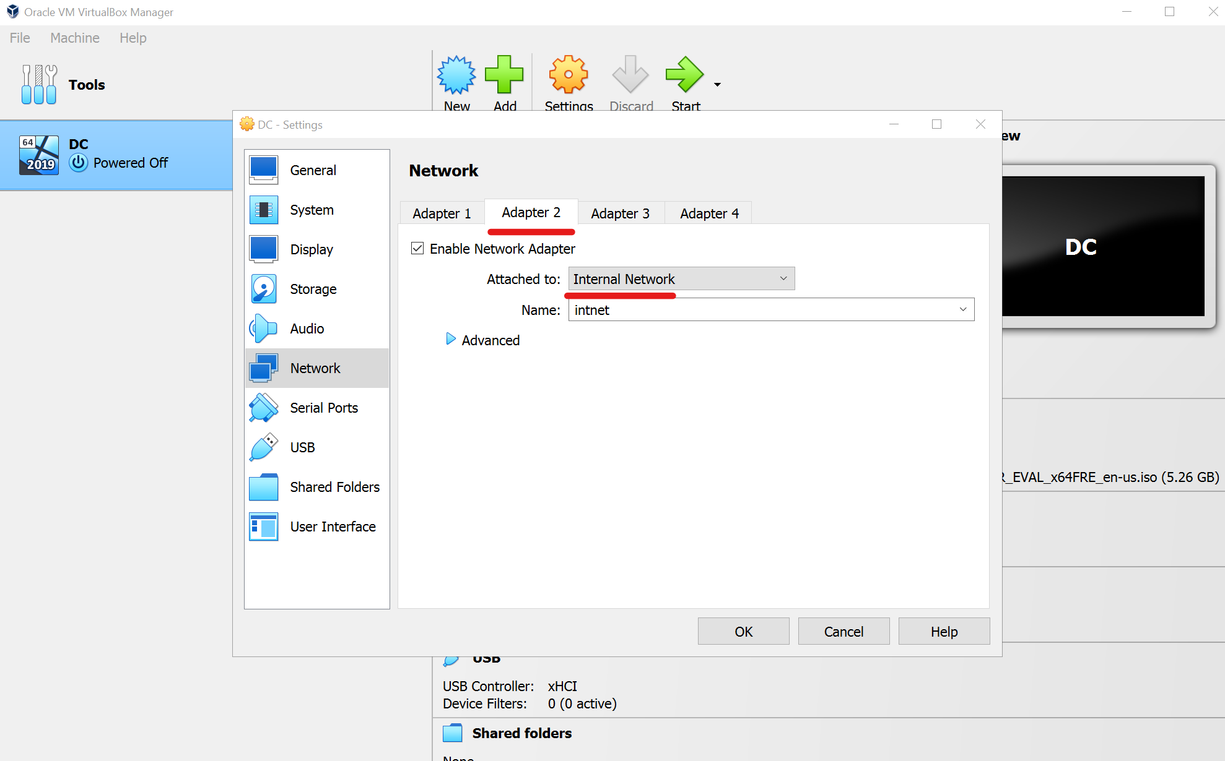

Settings for my future Netwok Home Lab

After all settings are made, you are ready to install the Windows operating system. Click the Start button to begin the installation. This will take some time to complete.

## **Conclusion**

Congratulations you have now successfully set up a virtual machine using Oracle VirtualBox and Windows.

**Why Virtualization Is Useful**

You can now run applications in a controlled environment. This isolation also facilitates flexible scalability, enabling IT environments to adapt to changing demands with ease. Moreover, virtualization simplifies disaster recovery efforts by encapsulating entire VMs into easily replicable files, ensuring swift restoration onto alternative hardware in case of system failures. Furthermore, it serves as an invaluable tool for testing and development, offering sandbox environments for software experimentation without disrupting production systems. Virtualization also enables the support of legacy applications on modern hardware, extending their lifespan and eliminating the need for outdated infrastructure maintenance.

Fo more information about VirtualBox and working with virtual machines here is a link:

[VirtualBox](https://www.virtualbox.org/)